REPORT of ASSIGNMENT 1

1. The validation of the cartype:

In the main Car d has car type “Taxi” which corresponds to Car 4 therefore there should be validation – (In the program that is sent, it is changed to a right type)

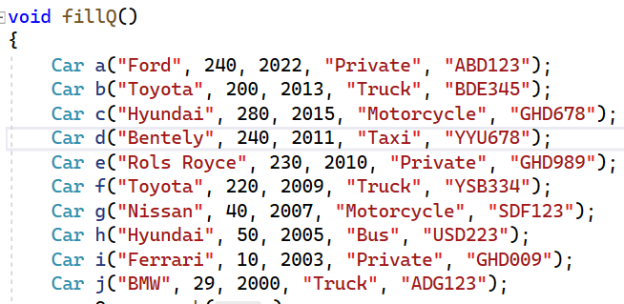

Output (In the next page):

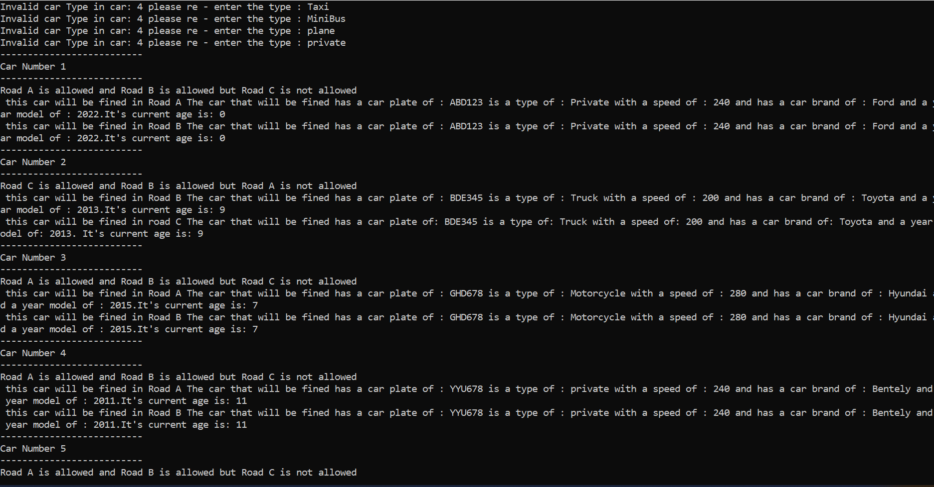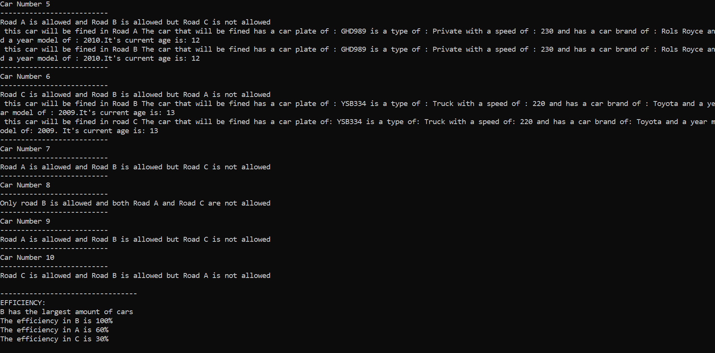

------------------------------------------------------------------------------------------------------------------------------------

1. The validation of the yearmodel

In Car c which corresponds to car number 3 the yearmodel is more than 2022 which should give an error (In the program that is sent, it is changed to a year less than 2022)

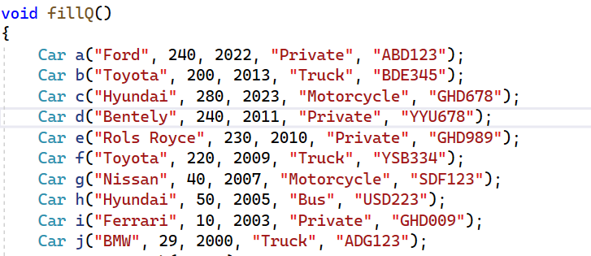

Output:

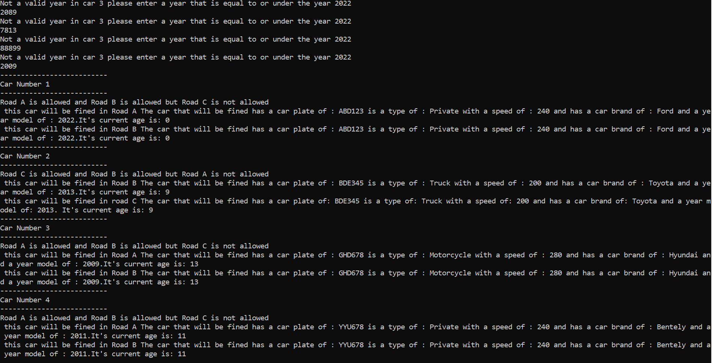

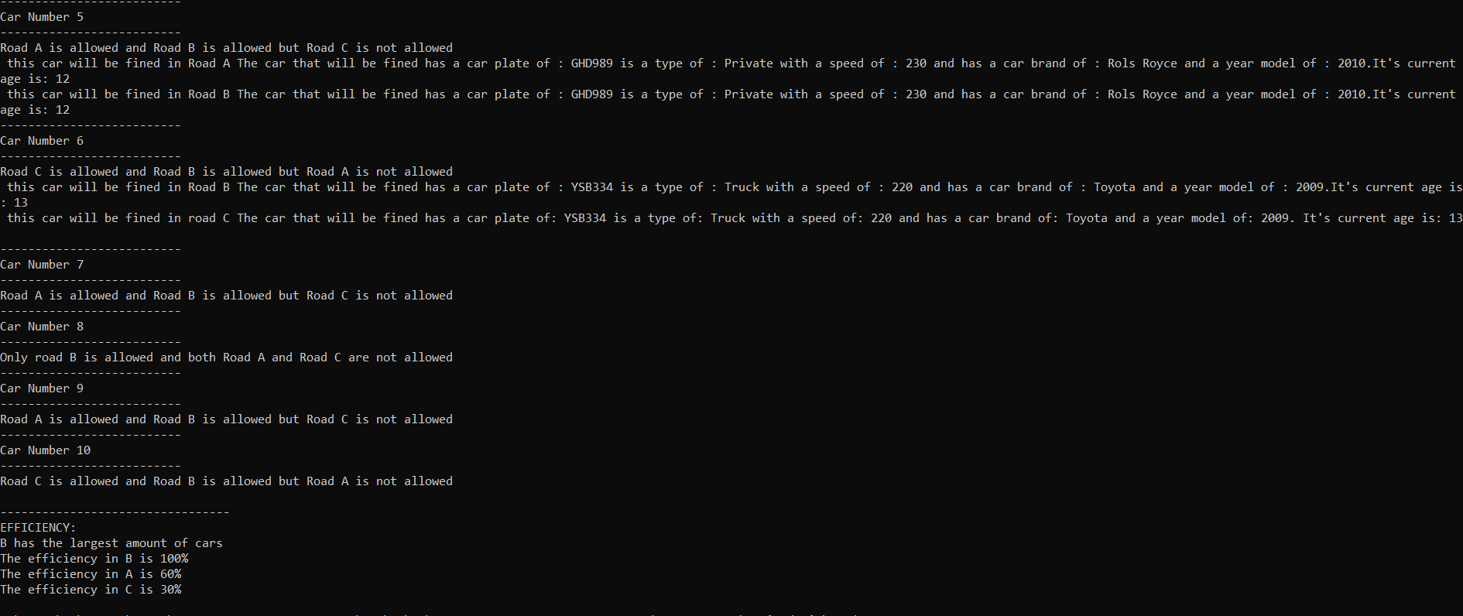

1. The validation of the car plate (3 UPPER CASE LETTERS AND 3 NUMBERS – TOTAL 6 LENGTH) (in the program that is sent, the right car plates are written)

Wrong input is in car i and car j (corresponds to car 9 and car 10 respectively)

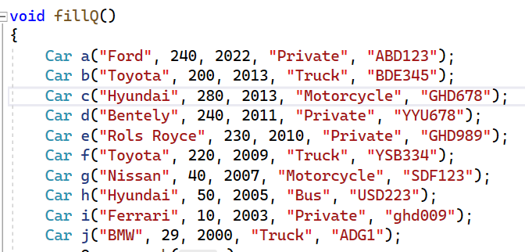

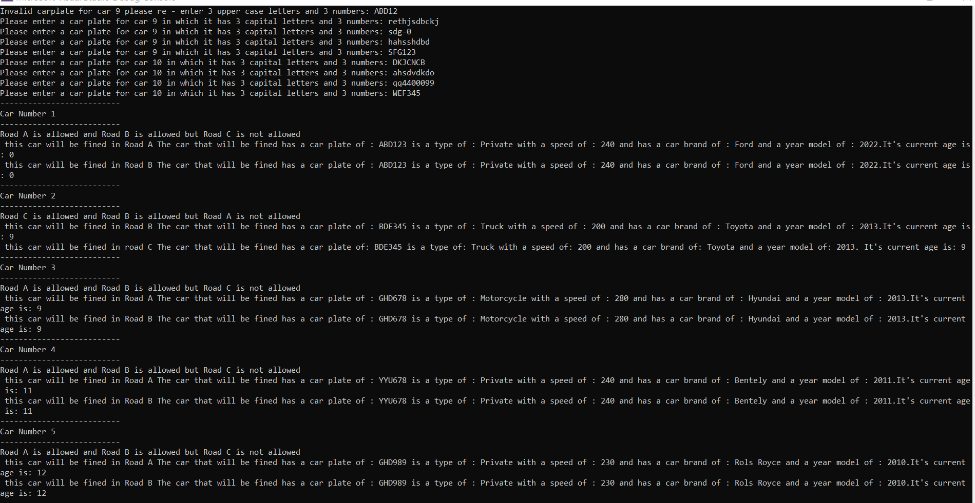

1. Using static int count in the private and incrementing it in the constructor in order to count of cars made. But adding to this use, I used it also in order to specify which Car object has an incorrect input

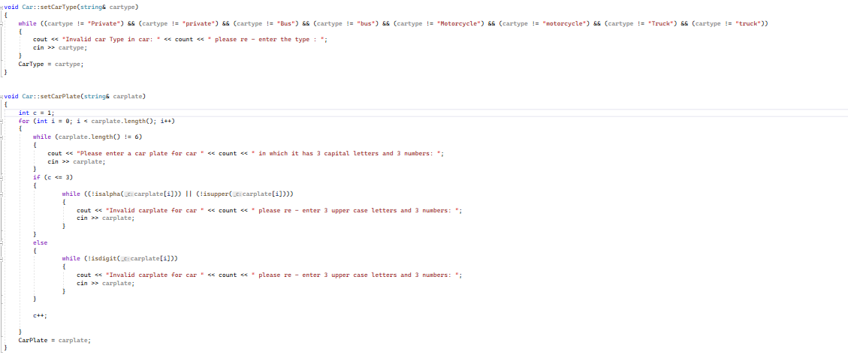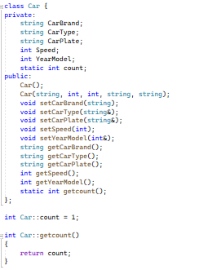The usage for specifying the number of the object car when a wrong input is given (we use count also in other functions for indicating the car number that corresponds to the wrong input):

1. Using the temps rather than creating 3 RoadObjects

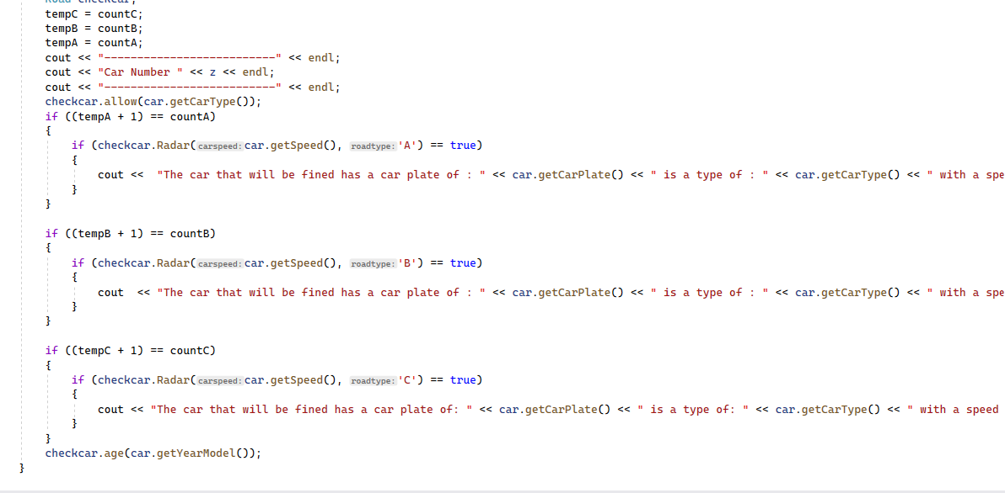

Of course using the 3 road objects are more understandable and has a clearer readability, however this was my first logical analysis that I created therefore I used it in the code and would like to explain

The explanation:

First we equate all the temps with their corresponding counts. Then we pass the object of carcheck to the function allow. In the roads that allow the car type of the current car object, their corresponding counts will increment. Therefore in order to know which road that the car type of the current car object was allowed in, we make an if statement that has the count value before it was incremented (stored in temp’letter’ and check if temp’letter’ + 1 == count (which is the value after being incremented)). If true then we pass Road object (checkcar) with its second parameter being the road type that corresponds to temp and the count in the if statement.